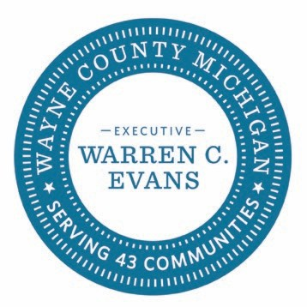

APPENDIX C to contract

Consortium Agreement & Terms

SOLICITATION #37-26-019 Jail Supply Items

The Procurement Division, on behalf of the County of Wayne (County), in compliance with the
County’s Procurement Ordinance, solicited bids/proposals for a consortium model contract with Wayne County as “Sponsoring Entity”. Wayne County Procurement has now completed the evaluation for the above referenced solicitation.

Cooperative Purchasing Consortium
The above reference solicitation was competitively bid and awarded. The Procurement Director, in accordance to Section 120-181, is sponsoring an agreement that has been designated as a cooperative contract and SUPPLIER NAME has agreed to extend their pricing to local municipalities, school districts and units of government within Wayne County and the State of Michigan. Wayne County Procurement is the sponsoring entity of this cooperative agreement under Michigan Association of Counties (MAC) CoPro+ program, a shared services solution program. All purchases under this agreement, either by the sponsoring entity or the ordering entity are subject to the administrative rebate fee.

Administrative Fees
An administrative rebate fee of 1.5% will be collected from SUPPLIER NAME on a quarterly basis. The fee will be calculated against the quarterly sales volume (actual sales) for all purchases made under this agreement. A request for Quarterly Sales Reports will be sent out from M.A.C. (Michigan Association of Counties). M.A.C. is the CoPro+ consortium administrator.

All administrative fees collected under the CoPro+ consortium will be distributed between M.A.C., Wayne County and CoPro+ members that place a sales order against this Master Agreement.

Signature
The County and the Supplier, by their authorized officers and representatives have executed this Addendum to the Contract.

By: Date:

Its:

Last updated 4/2/2021

